Calvary United Methodist Church
Sunday, April 25, 2021; 10:15 am
Welcome and Announcements
Prelude Dee Freeman
Call To Worship Psalm 9:1-2
I will give thanks to the LORD
with my whole heart; I will tell of all your wonderful deeds.
I will be glad and exult in you;
I will sing praise to your name, O Most High.
Invocation of the Spirit
Hymn Immortal, Invisible, God Only Wise
Psalter Psalm 23
"The Lord is my shepherd, I shall not want.
He makes me lie down in green pastures;
he leads me beside still waters;
he restores my soul.
He leads me in right paths
for his name’s sake.
Even though I walk through the darkest valley,
I fear no evil;
for you are with me;
your rod and your staff—
they comfort me.
You prepare a table before me
in the presence of my enemies;
you anoint my head with oil;
my cup overflows.
Surely goodness and mercy shall follow me
all the days of my life,
and I shall dwell in the house of the Lord
my whole life long." (NRSV)
Declaration of Praises
Sharing of Prayer Concerns
Prayer Time

Scripture Lesson Psalm 13
"O Lord, how long will you forget me? Forever?
How long will you look the other way?
How long must I struggle with anguish in my soul,
with sorrow in my heart every day?
How long will my enemy have the upper hand?
Turn and answer me, O Lord my God!
Restore the sparkle to my eyes, or I will die.
Don’t let my enemies gloat, saying, “We have defeated him!”
Don’t let them rejoice at my downfall.
But I trust in your unfailing love.
I will rejoice because you have rescued me.
I will sing to the Lord
because he is good to me. " (NLT)
Sermon Rev. Matthew Williams
Time to Pray: The Psalms
Closing Hymn In the Garden
Benediction
Postlude Dee Freeman

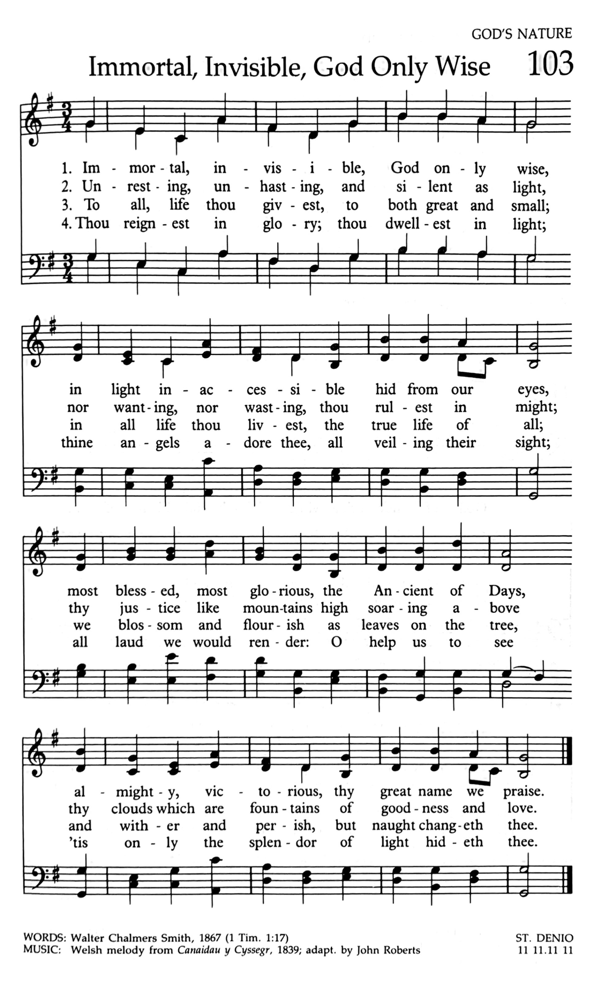

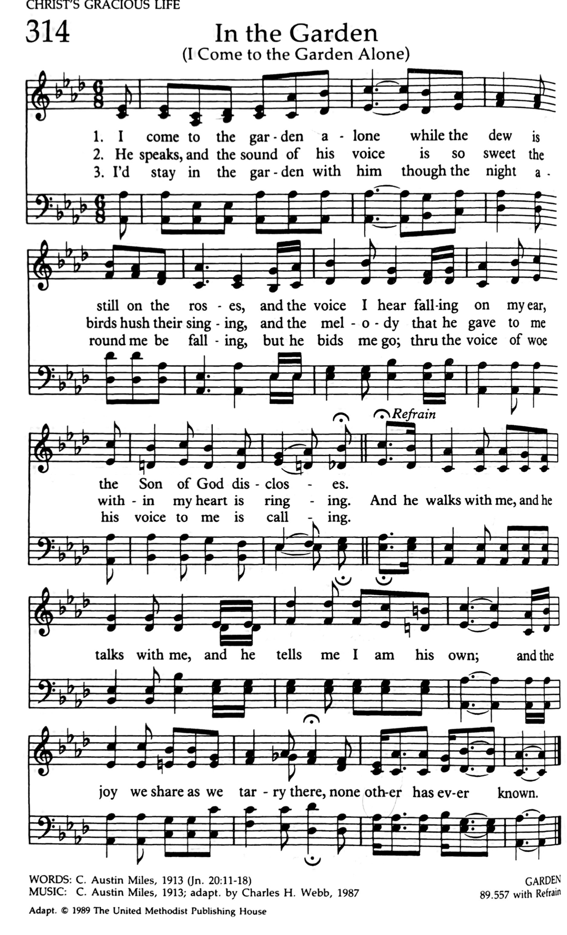

Announcements
- Please take the bulletins that you have touched home with you.

- Prayer Service
Prayer is a fundamental part of our lives as Christians. Sometimes, we need to create space to make prayer a priority. Join Pastor Matt on Wednesdays at 6:30 pm in the Chapel for a time of intentional prayer. The prayer service is planned to last until 7:00 pm.

- Women’s Book Study
Would you like to join a group of women to study the book, “Why Easter Matters” written by Andy Stanley? In this study, Andy looks at some of the people whose lives intersected with Jesus in the weeks leading to his crucifixion. It focuses on people we don’t hear much about during the Easter Season. Each of them had an agenda that put them at odds with God and Jesus…. The God Who Can Be Trusted. The Foundation of Our Faith. It will be a 4-week study lasting approximately one hour each week. We will be starting Tomorrow, Monday April 26th at 6:30 pm.

There is still space. If you are interested, contact Betsy Wagner at 814-536-0594 or 814-244-2993.

- Sunday School
Two of our adult Sunday School classes have returned to in-person meetings. You all are invited to join one of these groups at 9 am on Sundays. The “Seekers” met in the Fellowship Hall downstairs and the L³ Eagles meet in the Chapel area.

There is also a book study at 9 am on Sundays. They meet in the CC Classroom. Pastor Matt is leading a study of the book, Everybody Always by Bob Goff. Learn what it means to love without inhibition, insecurity, or restriction.

